PRESS RELEASE
February 25th, 2021

Divine Fortune™ Megaways™ goes live in New Jersey and Pennsylvania

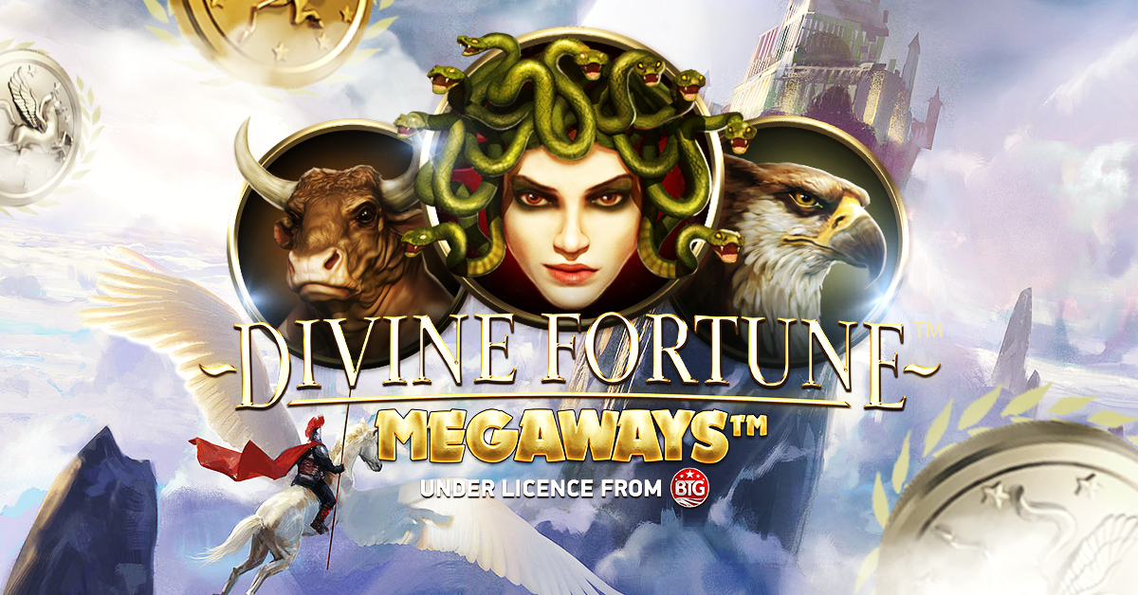

American players get hold of red-hot title that gives a MegawaysTM makeover to an all-time NetEnt classic

Divine Fortune™ Megaways™, one of NetEnt’s most successful game releases of 2020, is now available in the US, after going live with operators in New Jersey and Pennsylvania.
In this hotly-anticipated market release, NetEnt takes its original Divine Fortune™ title – which was the no.1 ranked online slot in New Jersey and Pennsylvania in 2020 according to iGaming Tracker – and adds the wildly popular random reel-modifying Megaways™ mechanic.
It marks the supplier’s second stateside Megaways™ launch, following the release of Twin Spin MegawaysTM in January 2021.
“We’re excited to have brought our Megaways™ collaboration to the US,” said Jeff Millar, Evolution Commercial Director, North America. “Aligning our top titles with the iconic Megaways™ feature brings something totally new to the US market. Twin Spin™ Megaways™, has been firmly embraced by players and I’m sure we’ll see the same with Divine Fortune™ MegawaysTM.
“And there’s plenty more to look forward to – we’ve got a packed roadmap of releases across Michigan, New Jersey, Pennsylvania and West Virginia.”
The 6-reel mythical-themed slot includes the same magical creatures and glittering coin symbols as the original Divine Fortune, but this time is loaded with 117,649 Megaways™ to win with a maximum win of 4,502x stake.
Divine Fortune™ Megaways™ features Falling Wilds Re-Spins, a Wild-on-Wild Expansion feature, and Free Spins with three collectable casino bonus symbols that can award an additional 500x bonus to create an experience packed with winning potential.
For additional information please contact:
press@evolution.com

NetEnt is a leading digital entertainment company and part of Evolution Gaming Group AB, the premium provider of online casino content. It supplies high quality gaming solutions to the world’s most successful online casino operators. Since its inception in 1996, NetEnt has been a true pioneer in driving the market with thrilling games powered by a cutting-edge platform. With innovation at the core of the company ethos, its talented team takes pride in delivering flexible digital casino solutions, so that its network of more than 200 global partners can provide their players with the best in immersive entertainment. NetEnt holds licenses in Alderney, Belgium, Gibraltar, Malta, Romania, Spain, and the UK, as well as the U.S. states of Michigan, New Jersey, Pennsylvania and West Virginia. Learn more at: www.netent.com

