Press release 08/07/2021

NetEnt celebrates two wins at this year’s EGR B2B Awards including Mobile Gaming Software Supplier

This year has seen NetEnt, recently acquired by Evolution Group, receive two accolades at the EGR B2B Awards. Fredrik Bjurle, Director of Product at Evolution Group accepted the awards on the group’s behalf and commented on what this means for the brand moving forward.

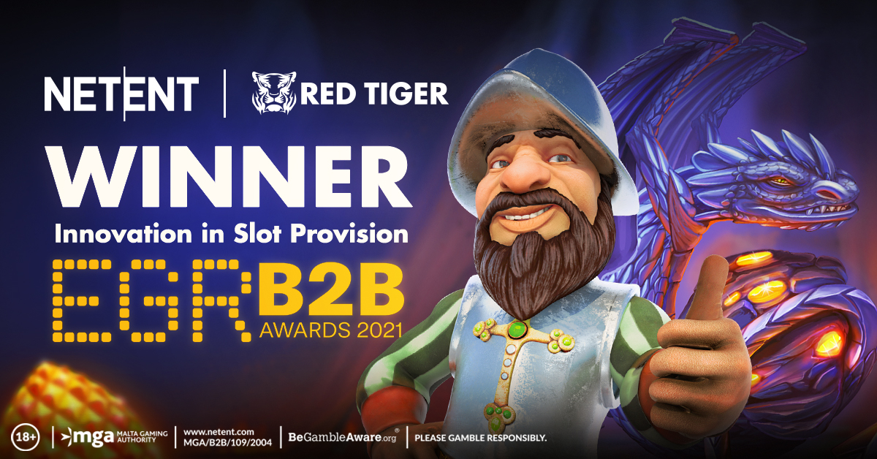

After two days of virtual ceremonies and a final in-person event in Regent’s Park, London, the EGR B2B Awards saw NetEnt celebrating two award wins – including Mobile Gaming Software Supplier.

The first award focuses on product development, flexibility, the user interface and experience, and innovation. NetEnt this year walked away as winner of Mobile Gaming Software Supplier, ahead of 13 other suppliers who were vying for the award. The judges commented that the brand had “superb performance throughout the US market specifically”.
This year also saw a joint entry win for NetEnt and Red Tiger in the Innovation in Slot Provision category, beating 13 other prospective suppliers. In a classification that looks to celebrate product differentiation, user experience, and product development and deliverability judges were impressed by the “fantastic combination of expertise and experience” of the brands. Judges said there were “some hugely successful new launches in a very competitive market”, and the award recognises the collaborative development of Gonzo’s Quest Megaways™, Kulta-Jaska Megaways™ and Dragon’s Fire INFINIREELS™.
Evolution itself was awarded Live Casino Supplier of the Year, beating eight other shortlisted suppliers in an incredible unbroken run of 12 wins in that category, stretching back to when the EGR B2B Awards first launched in 2010.
Accepting the awards on behalf of Evolution, NetEnt and Red Tiger, Fredrik Bjurle, Director of Product at Evolution Group, said: “For Evolution Group brands to be voted the top suppliers in so many award categories is a very great honour. NetEnt has been a wonderful addition to the Evolution family, bringing years of experience and a name that’s becoming synonymous with flexibility and originality. Our aim here at NetEnt remains to set a standard for playability and performance, and we’re always looking to progress and adapt our service offering to give the market something exceptional. Looking to the future we’re going to be producing more innovative games, using the brilliant minds in the group to start mixing RNG, slots and live game principles. We look forward to taking on the new set of challenges that this will present, and to continue working with a remarkable set of people.”

Officiated by Deloitte, the EGR B2B Awards reward and celebrate the very best service providers in the online gaming industry, recognising the achievements of suppliers from across all the major egaming disciplines including: betting and gaming software; networks; mobile; payments; recruitment; IT and infrastructure.

For trade press and media enquiries, please contact:
press@evolution.com

